Linux Distributions and Setup for IT 316 (Kali Linux Setup)

- Step 1: Go back to the web site https://www.virtualbox.org/wiki/Downloads
- Step 2: Go to the ‘Virtual Box Platform Packages’
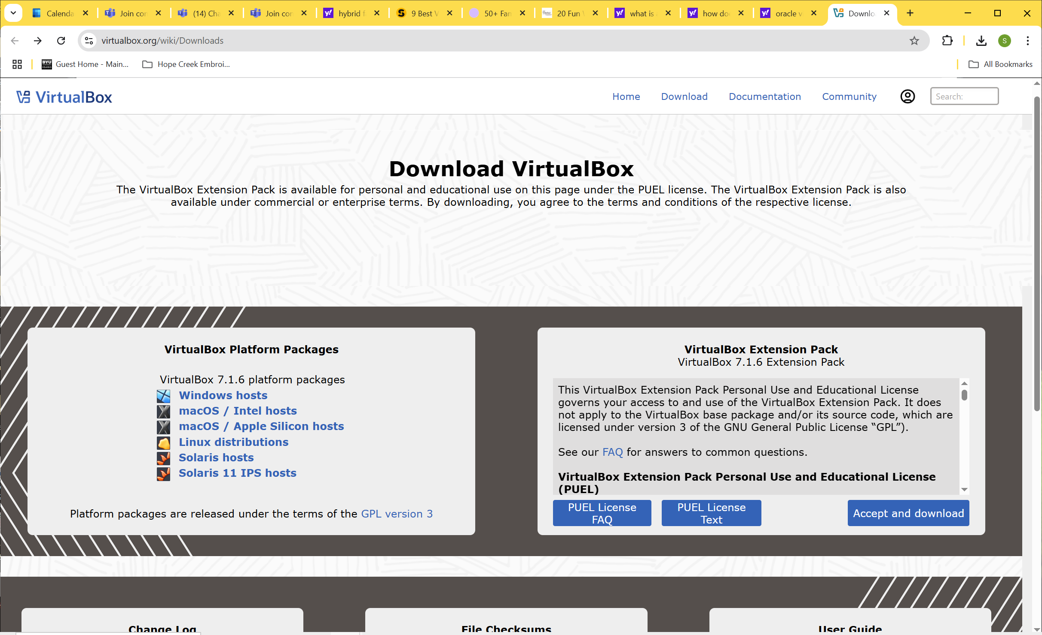
- Step 3: We can now download the files that we can use to create virtual machines so we don’t mess up or utilize our own computer when we start ‘messing’ or ‘experimenting’ with our scripting or fun exercises in the course
- Step 4: First, lets download two Linux distributions:
  - A. Kali-Linux
  - B. Ubuntu 24.10 (will be the next file)
- Step 5: Go to a browser window and insert this link in the URL line https://www.kali.org/get-kali/#kali-virtual-machines
- Step 6: Go to Virtual Box and click n the 3.2 G symbol under the VirtualBox icon – you will see a file go to Downloads – NOTE: the information on the top of the main screen that says the credentials for each of these virtual machine images are “kali/kali”
- Step 7: When download of the 3.2 G .iso file is complete verify this in your Downloads folder
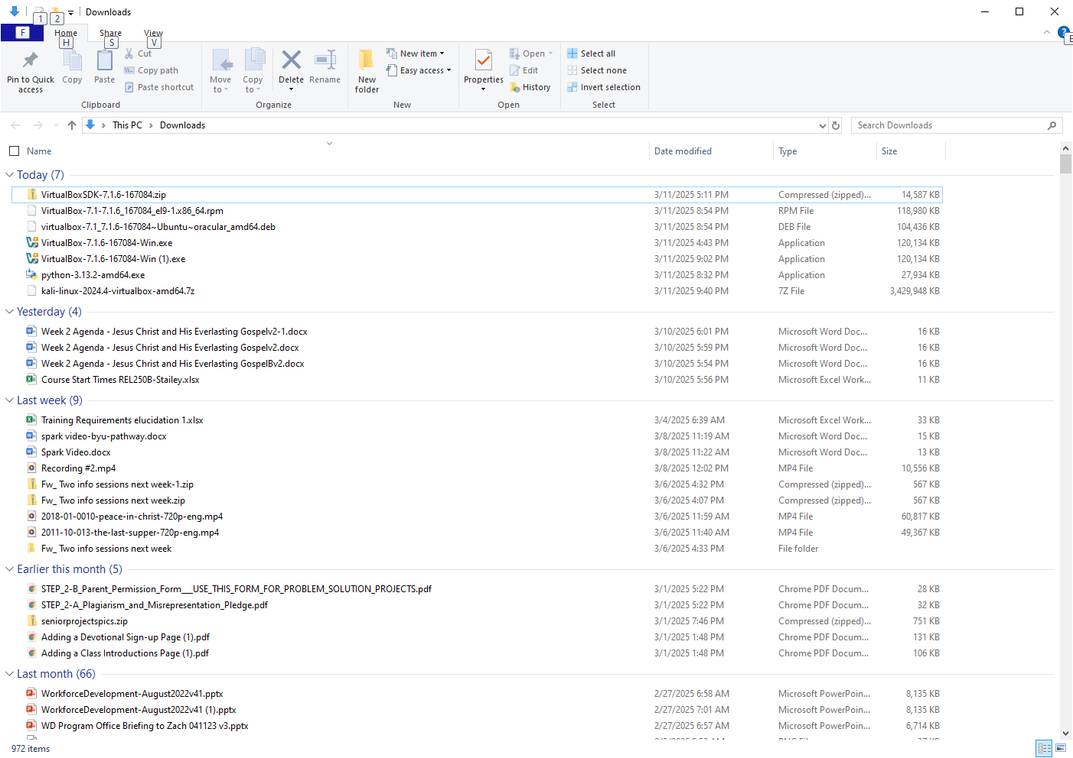
- Step 8: ~~ NOTE: because it is a 7z file you will need to go to this link to extract the virtual image to a .vbox file using a tool called the ‘official 7z app’.
See – from the Docs link https://www.kali.org/docs/virtualization/import-premade-virtualbox/

- Step 9:
Download and install the 7-zip application for 64 bit windows from 7-zip.org

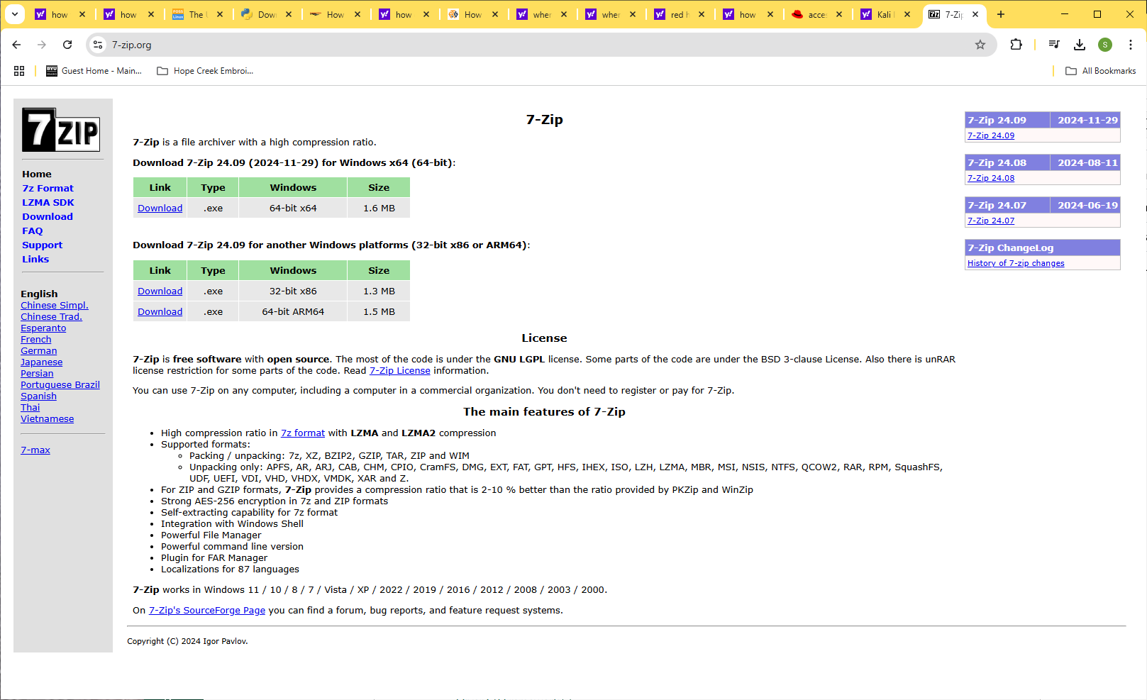

- Step 7: Go to Downloads folder and run 7z2409-x64.exe
- Step 8: Click ‘Yes’ to start the Installation
- Step 9: Assume defaults and click ‘Install’
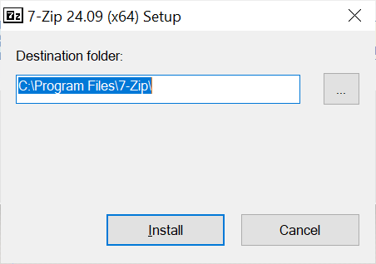
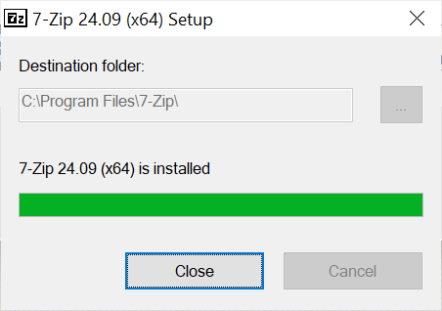
- Step 10: Go to Downloads folder and extract the file using the 7-zip application:
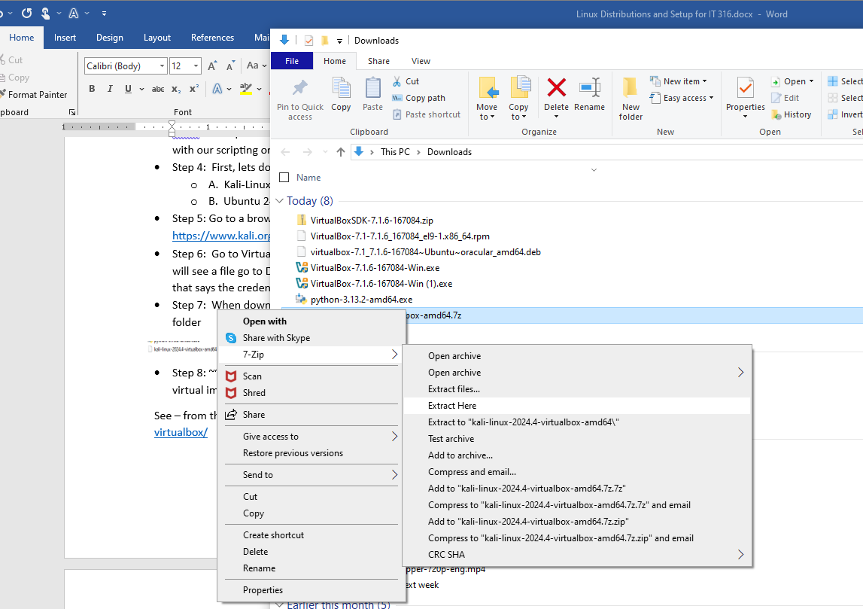

- Step 11: Specify your ‘Extract Here’ or ‘Extract Files’ location and extract the files to your computer:
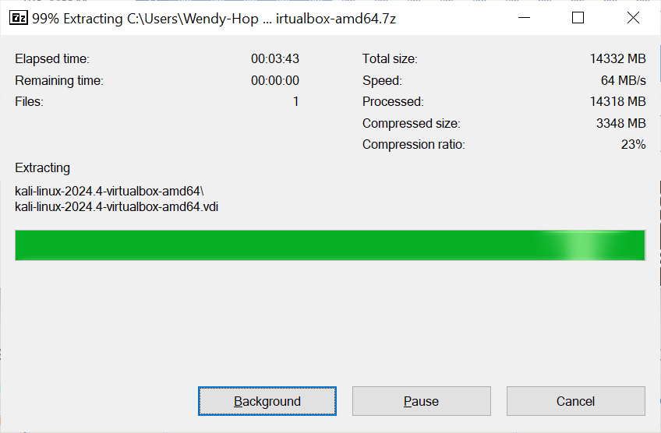

- Step 12: Follow the directions found on the following web site to create your Kali-Linux Virtual Machine: https://www.kali.org/docs/virtualization/import-premade-virtualbox/
- You will be ‘Adding’ the following file from your extracted location as follows >> then click ‘Open’
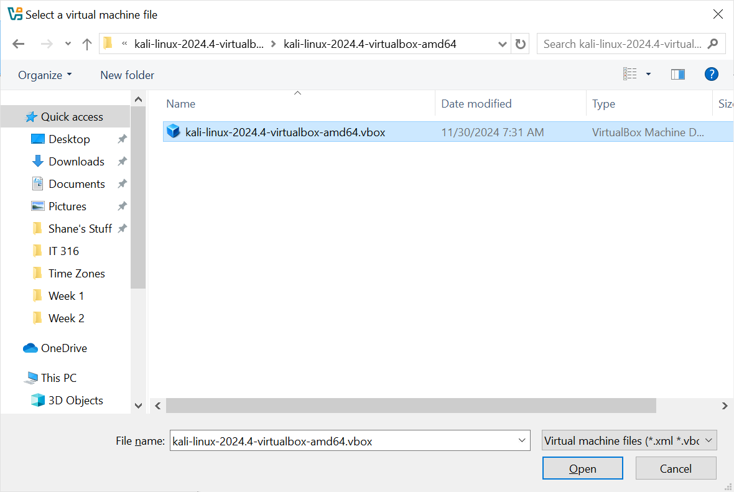

- Step 13: I should now have a Kali-Linux VM in my Oracle Virtual Box that looks like this:
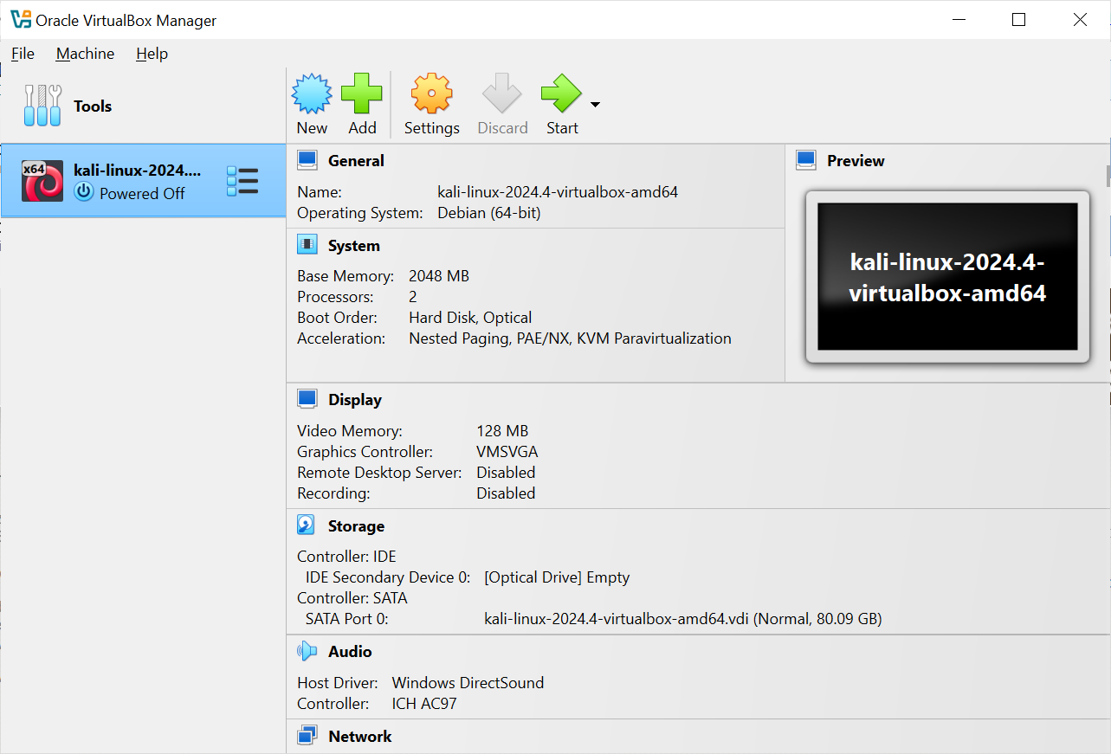
- Step 14: I can now ‘Power On’ my Kali Linux virtual machine and start playing with things
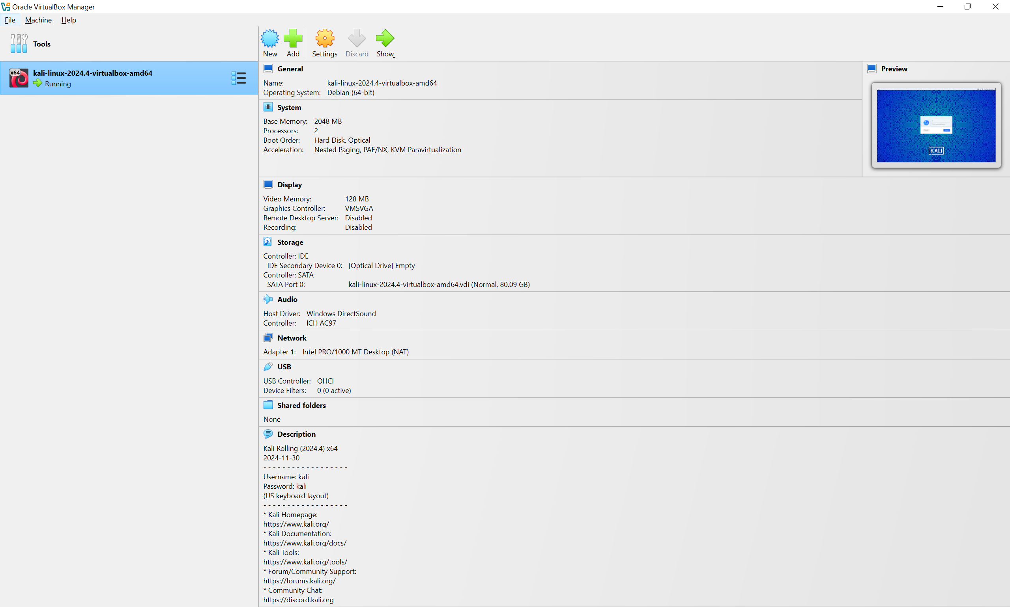

- Step 15: Once the virtual machine is running in the ‘Preview’ window click on the big green arrow that says ‘Show’
- Remember the default credentials were kali / kali
- You are now on your full Kali virtual machine window – just adjust it to Full Screen
